**Name: Gaurang Vaghela**

**Rollno: TEAD-22561**

**DS (SL-III)**

**Practical 6**

**Code:**

**1. Import libraries, load and process ‘Iris.csv’ dataset.**

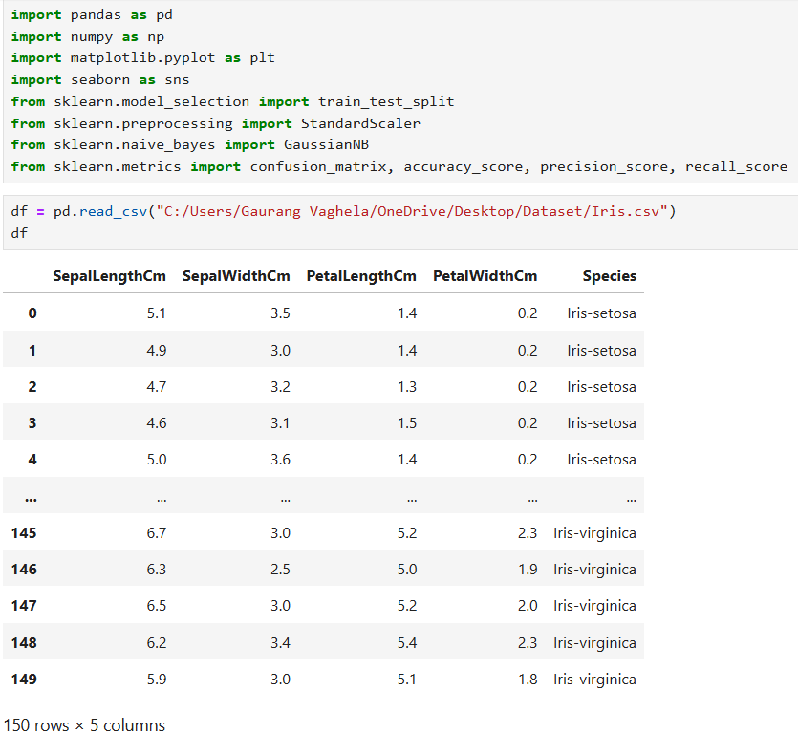

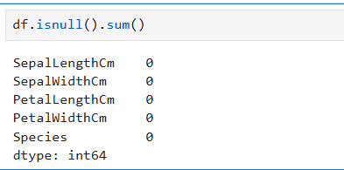

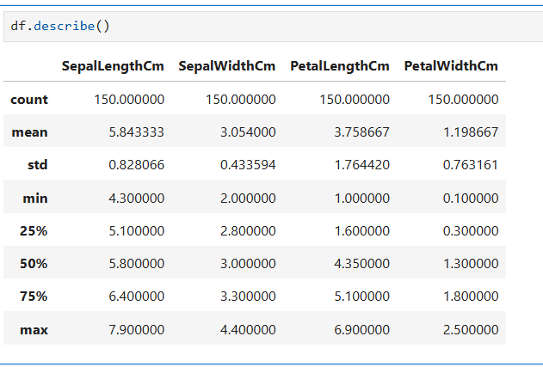

**2. . Implement Simple Naïve Bayes classification algorithm using Python/R on iris.csv**

**dataset.**

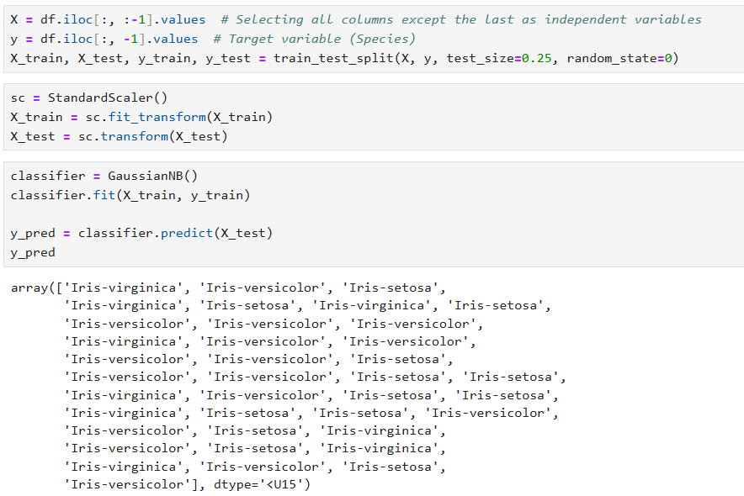

**3. Compute Confusion matrix to find TP, FP, TN, FN, Accuracy, Error rate, Precision, Recall**

**on the given dataset.**

